**4ITRC2 Operating System Lab**

**Lab Assignment - 02  
Study and Execution of Ubuntu Commands**

**Part 1: Outputs of the Given Commands**

Here’s a brief explanation of each command and its output:

1. **pwd** – Displays the present working directory.

pwd

**Output Example:** /home/user

1. **cd** – Changes the directory.

cd /path/to/directory

**Example:** cd my_folder/ moves to the Documents folder.

1. **ls** – Lists files and directories in the current directory.

ls

**Example Output:** file1.txt file2.txt folder1 folder2

1. **mkdir** – Creates a new directory.

mkdir my_folder  
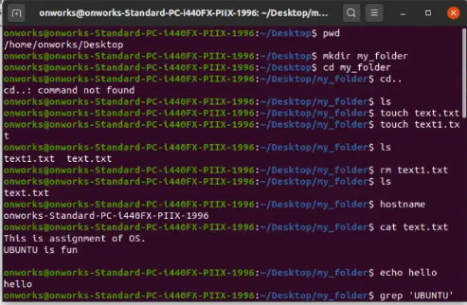

**Creates a directory named myfolder.**

1. **rm** – Removes files or directories.

rm text1.txt

**Deletes file1.txt.**

1. **touch** – Creates an empty file.

touch text1.txt

**Creates newfile.txt.**

1. **hostname** – Displays the system's hostname.

hostname

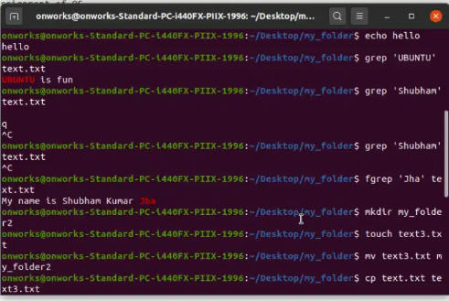

**Output Example:** ubuntu-PC

1. **cat** – Displays the content of a file.

cat text.txt

**Shows the content of file1.txt.**

1. **chmod** – Changes file permissions.

chmod 777 myscript.sh

**Grants full permissions to myscript.sh.**

1. **echo** – Prints text to the terminal.

echo "Hello"

**Output:** Hello

1. **grep** – Searches for a pattern in a file.

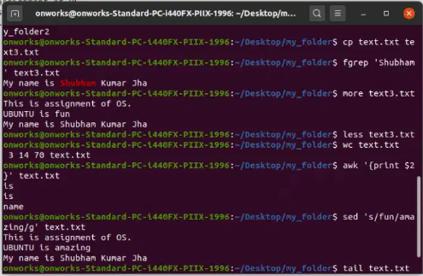

grep "Jha" text.txt

**Finds lines containing "Jha" in text.txt.**

1. **fgrep** – Searches for a string without processing special characters.

fgrep "Shubham" text.txt

**Finds the exact email address.**

1. **mv** – Moves or renames files.

mv text.txt text1.txt

**Renames oldname.txt to newname.txt.**

1. **cp** – Copies files or directories.

cp file1.txt /backup/

**Copies text3.txt to the backup directory.**

1. **more** – Views file content page by page.

more text.txt

**Displays content page by page.**

1. **less** – Similar to more, but allows backward navigation.

less text.txt

**View file with scrolling options.**

1. **wc** – Counts words, lines, characters in a file.

wc text.txt

**Output Example:** 10 100 500 file.txt (Lines, Words, Characters).

1. **awk** – Processes and formats text.

awk '{print $1}' text.txt

**Prints the first column of file.txt.**

1. **sed** – Stream editor for modifying text.

sed 's/fun/amazing/g' text.txt

**Replaces all occurrences of "old" with "new".**

1. **tail** – Displays the last 10 lines of a file.

tail text.txt

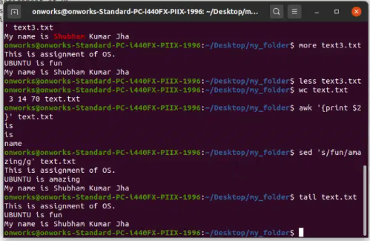

**Shows last 10 lines of file.txt.**

**Part 2: Answers to the Given Questions**

1. **How to navigate to a Specific Directory?**

cd /path/to/directory

Example: cd /home/user/Documents/

1. **How to see detailed information about files and directories using ls?**

ls -l

**Displays file permissions, owner, size, and modification date.**

1. **How to create multiple directories in Linux using mkdir?**

mkdir dir1 dir2 dir3

**Creates dir1, dir2, and dir3.**

1. **How to remove multiple files at once with rm?**

rm file1.txt file2.txt file3.txt

**Deletes multiple files.**

1. **Can rm be used to delete directories?**  
   Yes, use:

rm -r directory_name

**Deletes a directory and its contents.**

1. **How Do You Copy Files and Directories in Linux?**

cp file.txt /destination/

cp -r folder/ /destination/

**Copies files or entire directories.**

1. **How to Rename a file in Linux Using mv?**

mv oldname.txt newname.txt

1. **How to Move Multiple files in Linux Using mv?**

mv file1.txt file2.txt /destination/

1. **How to Create Multiple Empty Files Using touch?**

touch file1 file2 file3

1. **How to View the Content of Multiple Files?**

cat file1.txt file2.txt

1. **How to Create a file and add content using cat?**

cat > newfile.txt

**Then type content and press Ctrl+D to save.**

1. **How to Append the Contents of One File to Another?**

cat file1.txt >> file2.txt

1. **How to use cat for large files?**

cat largefile.txt | less

1. **How to Merge Multiple Files Using cat?**

cat file1.txt file2.txt > merged.txt

1. **How to Append to an Existing File Using cat?**

cat >> existingfile.txt

**(Then type text and press Ctrl+D).**

1. **What is chmod 777, chmod 755, and chmod +x?**
   * chmod 777 file → Grants **full permissions** (read, write, execute).
   * chmod 755 file → Grants **read & execute** for others but **write** only for the owner.
   * chmod +x file → Makes the file **executable**.
2. **How to find the number of lines that match a pattern?**

grep -c "pattern" file.txt

1. **How to display files containing a pattern?**

grep -l "pattern" *.txt

1. **How to show line numbers with matched text?**

grep -n "pattern" file.txt

1. **How to match lines starting with a string?**

grep "^pattern" file.txt

1. **Can sort sort files in descending order by default?**  
   No, but we can use:

sort -r file.txt

1. **How to sort a file based on a specific column?**

sort -k2 file.txt

-BY SHUBHAM JHA   
 23I4167  
 BE 2ND IT – ‘B’